https://intjbilling.com

INTJ Billing Pty Ltd sole proposed use of the Zeller EFTPOS Terminal

- Use of Terminal: If granted access to the Zeller payments system INTJ Billing agrees to use the Zeller terminal and associated infrastructure exclusively and only for accepting payments from KYC/AML verified and identification verified in-person, face-to-face clients at INTJ Billing’s premises located at 7 Cullen Court Spotswood, Victoria 3015 AUSTRALIA.
- Limited Use Case for Zeller Terminal. Exclusive Use for In-Person Consultation Payments: INTJ Billing simply has no need or requirement to use the Zeller terminal for any use case related to accepting payment for Bitcoin as INTJ Billing does not sell Bitcoin to clients. INTJ Billing only requires an EFTPOS terminal for client convenience so clients can pay INTJ Billing solely and exclusively for hourly in person consultations using their debit and credit cards with ‘tap and go’.
- Compliance: INTJ Billing agrees to comply with all relevant laws, regulations, and industry standards, including but not limited to Know Your Customer (KYC) and Anti-Money Laundering (AML) requirements.
- Limitation of Use: INTJ Billing agrees not to use the Zeller terminal for processing payments related to any goods or services that are prohibited by Zeller's Terms of Service.
- Indemnification: INTJ Billing agrees to indemnify and hold harmless Zeller from any claims, damages, or liabilities arising out of or related to the INTJ Billing’s use of the Zeller terminal.
- Term and Termination: This Agreement shall remain in effect until terminated by Zeller. Zeller may terminate this Agreement immediately if INTJ Billing uses the Zeller terminal for any use outside of the proposed use case of accepting payments for in person face to face hourly consultations from KYC/AML verified and identification verified clients at INTJ Billing’s premises located at 7 Cullen Court Spotswood, Victoria 3015 AUSTRALIA.
- Governing Law: This Agreement shall be governed by and construed in accordance with the laws of the state of Victoria, Australia.

Yours Sincerely,

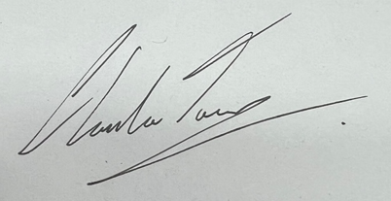
Clarke Towson
Tuesday 16th April 2024

Clarke Towson, BCMS (Bachelor of Computer & Mathematical Science)
CEO
INTJ Billing
m: +61 432 359 166
a: 7 Cullen Court Spotswood Victoria 3015 AUSTRALIA
w: https://intjbilling.com
e: clarketowson@intjbilling.com

Microsoft Digital Certificate Number:
FF116911EC521DDF424CBCEAF5B5560D1F6E8B8C
Issued to: intjbilling.com
Issued: 23/3/2024

